**PF ASSIGNMENT – 09**

**QUESTION#1**

As a programmer, you are required to create a program that takes the first and last name from a user. The program then combines both the inputs taken and prints the string backwards.

CODE:

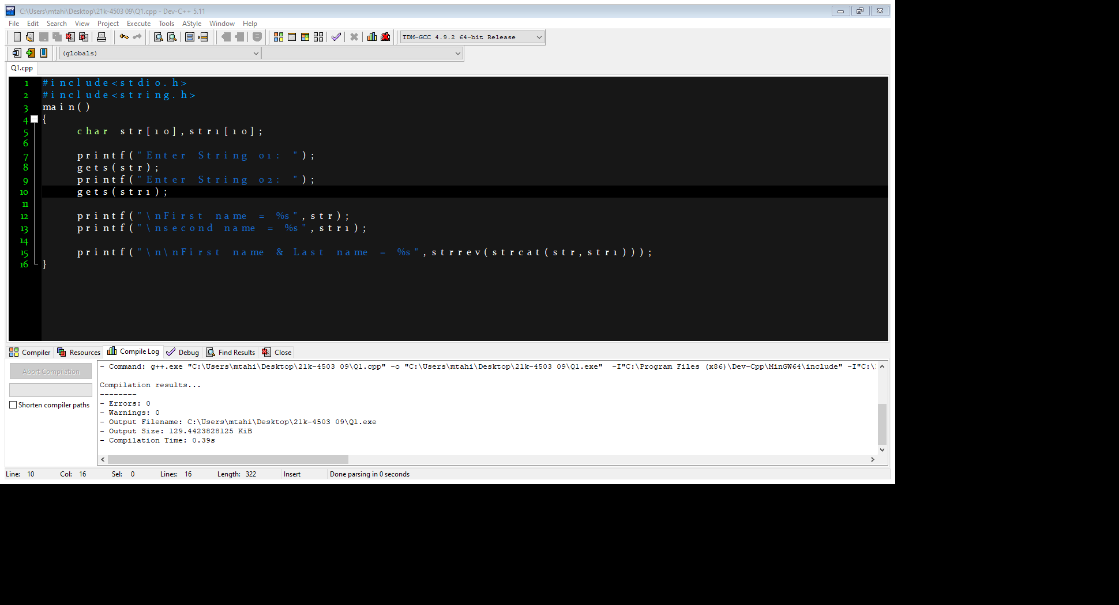

OUTPUT:

**QUESTION#2**

Each student is required to find out the maximum frequency of characters occurring in the courses offered in Fall 2021. To find it, the student enters their course offered and the program finds the maximum occurrences of a character in the name and course. Course names should be used like Programming Fundamentals, Applied Physics, Pakistan Studies and so on.

CODE:

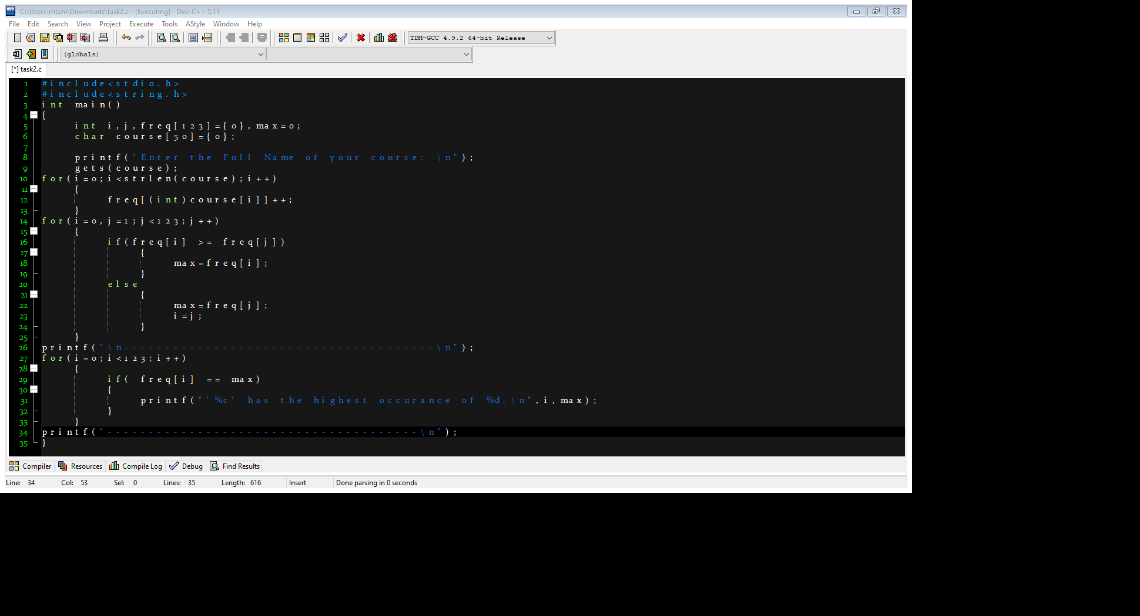

OUTPUT:

**QUESTION#3**

Venture Dive is one of leading software house they are starting their recruitment process for three different following positions:

1. Associate Developer

2. Assistant Developer

3. Trainee Engineer

There is defined criteria for recruitment process, if candidate clear the test with 50 marks then he will be select for the post of trainee engineer, experience are not the requirement in it. If candidate secured 60 marks with one or more than one year of experience, then he/she will be selected as the assistant developer. If the candidate secured 70 marks with 2 year or more than two years of experience, then he/she will be selected as associate developer respectively. Write a function that will take a test marks from user and ask for experience (if its entered marks x & g t; =60). After that, function will show the assigned position.

CODE:

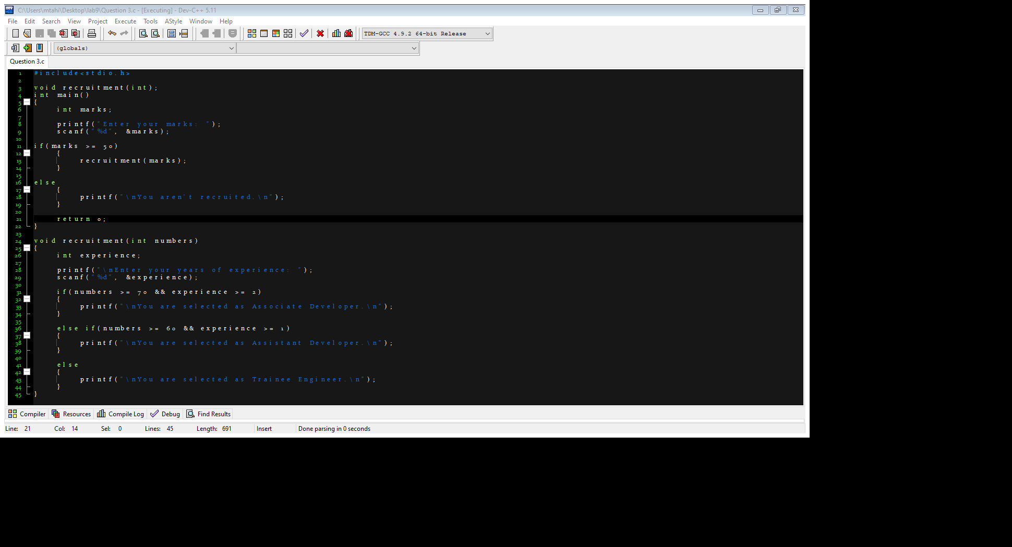

OUTPUT:

**QUESTION#4**

You need to declare an array of 5 x 9 elements. In which first 1st column contains the Student ID and its respective 5 courses obtained marks in following 5 five columns for the semester. In rest of 4 columns total marks, obtained marks, and Percentage as shown in given table.

1. Initialize the array with its default value.
2. You need to take user input for the first 6 columns.
3. Total marks, obtained marks, and Percentage columns will be filled by your program on the basis of required logic for each of the columns.

CODE:

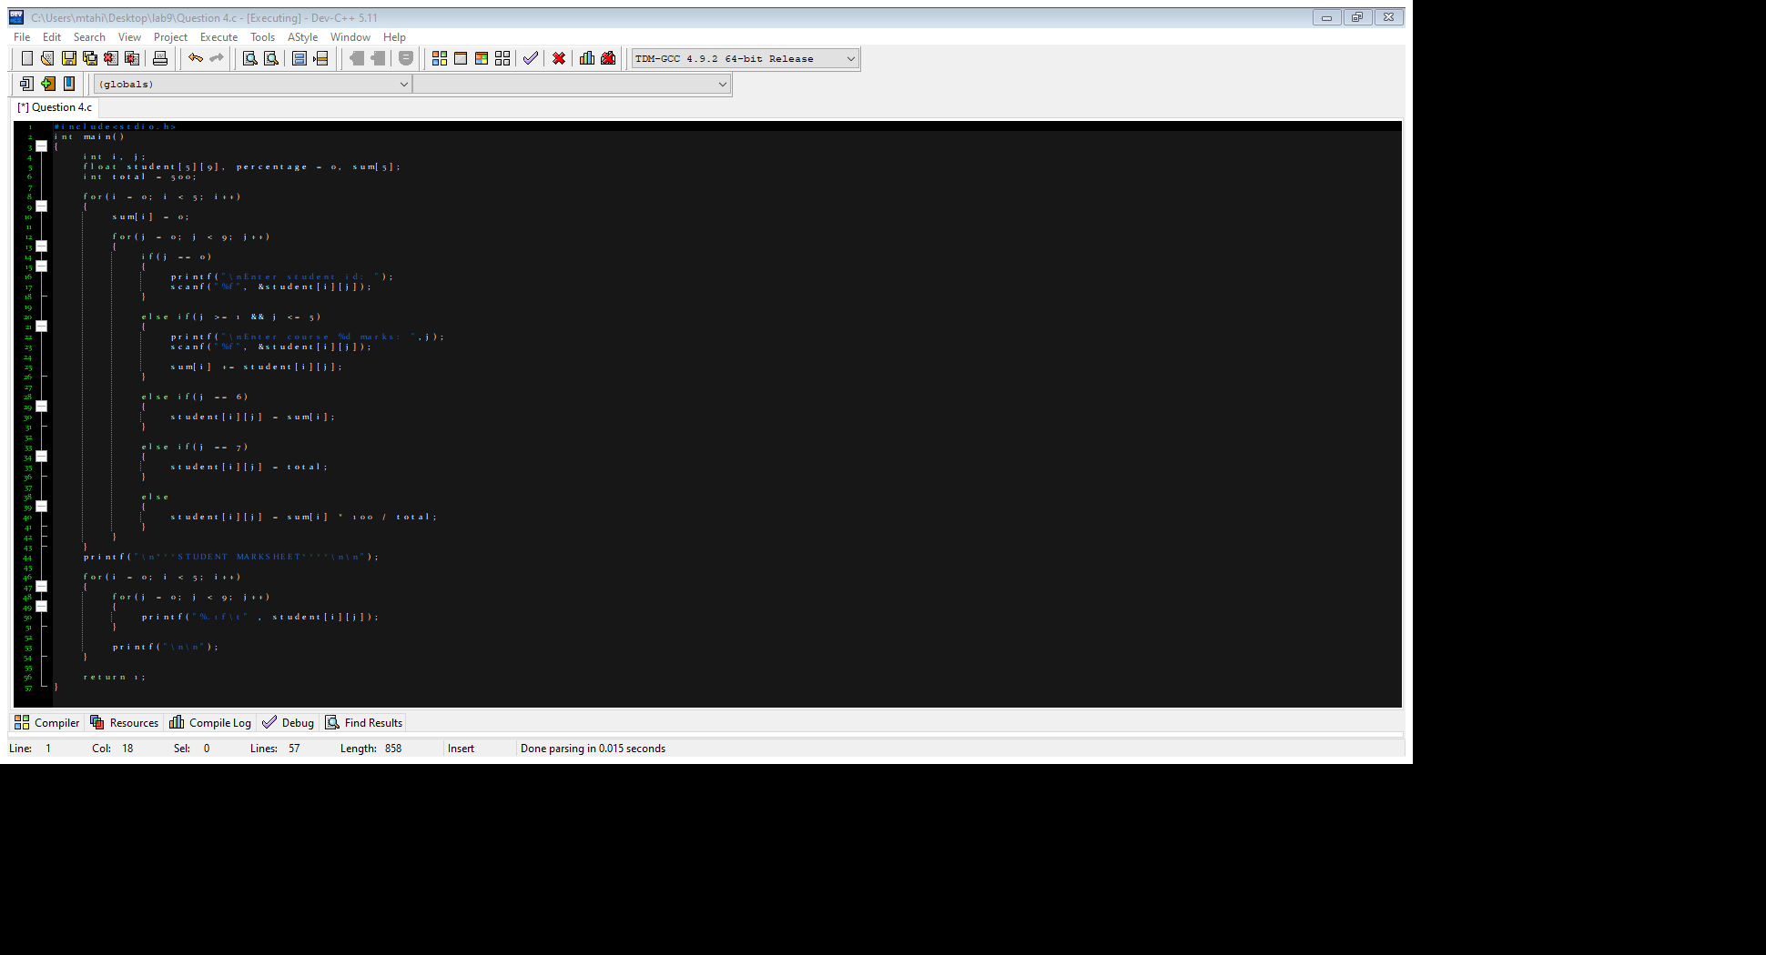

OUTPUT:

**QUESTION#5**

Write the program that calculate the volume create a two separate function

h = a*a *2 ∗ 1 /3 ℎ

1. One function with the name of “getData (int h, int a)”, that will take two input from user for the variable of “h” and “a”.

2. Second function “volumeCalu ()” will calculate the volume and function must be called by first function “getData ()”. Only first function call from the main function.

CODE:

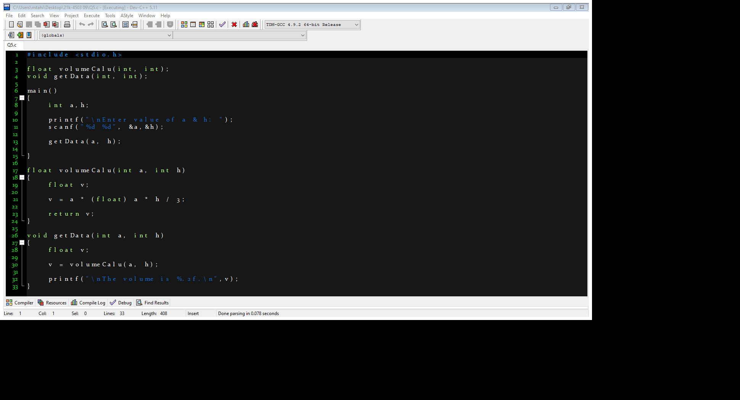

OUTPUT:

**QUESTION#6**

Write a program that take your 4 digit roll no as input. Pass it to the function, the function should check if the number is prime or not. If the number is prime return 1, save the returned value in the variable and check if the values is 1 then the number is prime else the number is not prime.

CODE:

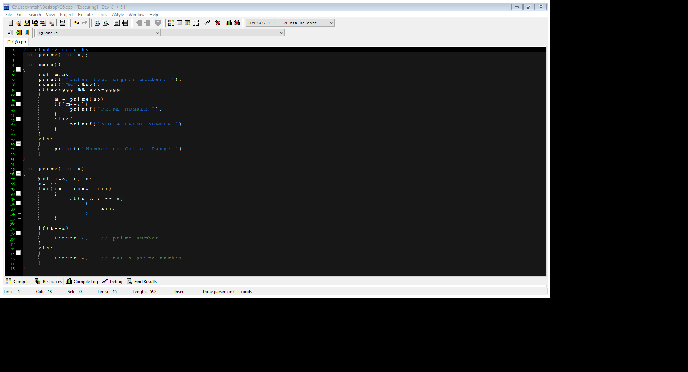

OUTPUT:

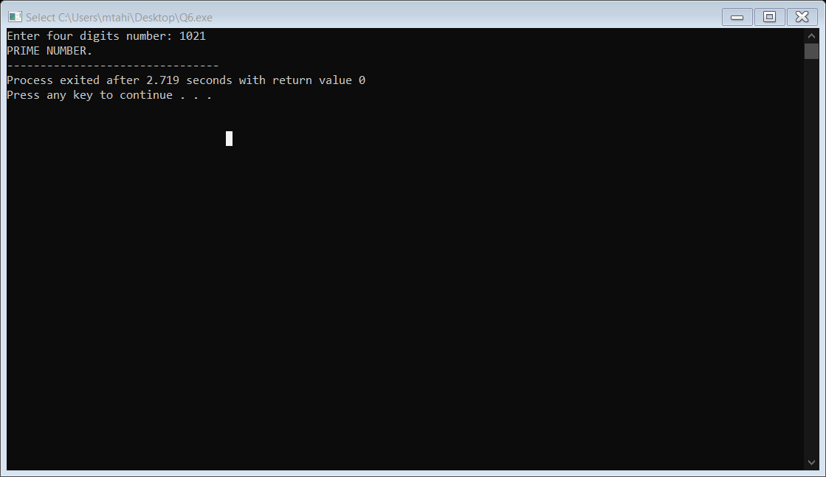

**QUESTION#7**

FAST-NU enrolled more than 1200 students in undergrad program and planning to register more students in coming year. To achieve the objective, they are looking for nearby land to be purchased. They can find out the following 8 pieces of lands which are rectangle in shape. write down a program to find the out the area of land pieces and also determine which land is largest.

CODE:

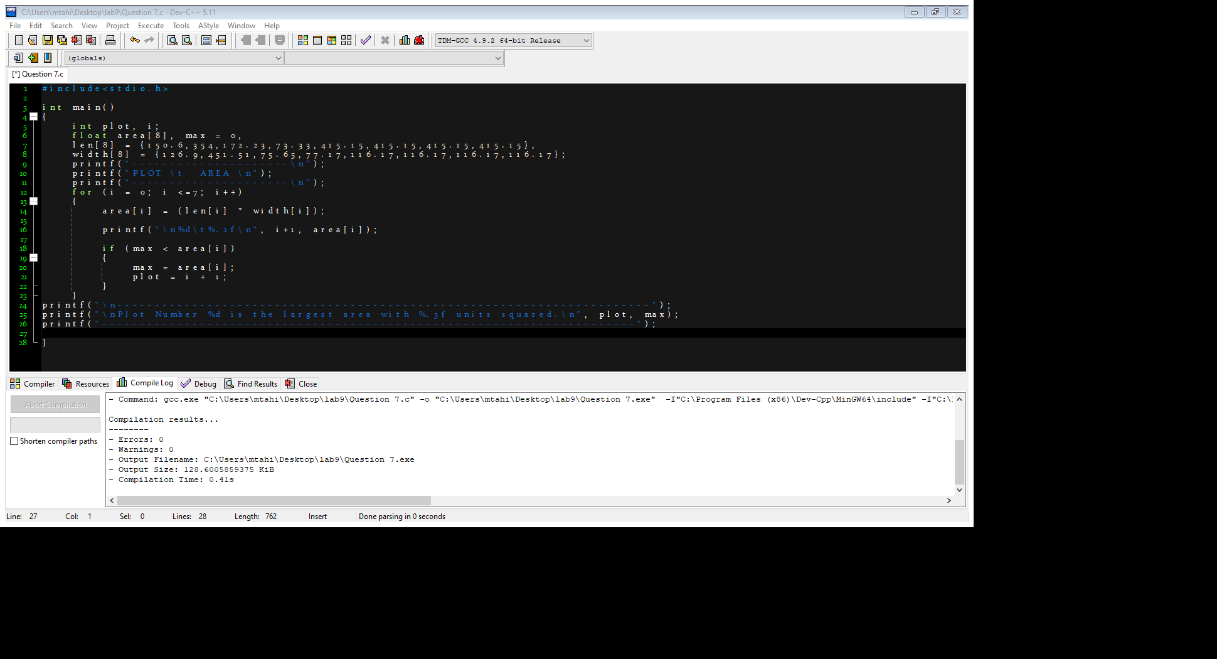

OUTPUT:

**QUESTION#8**

Write the program for the following output.

CODE:

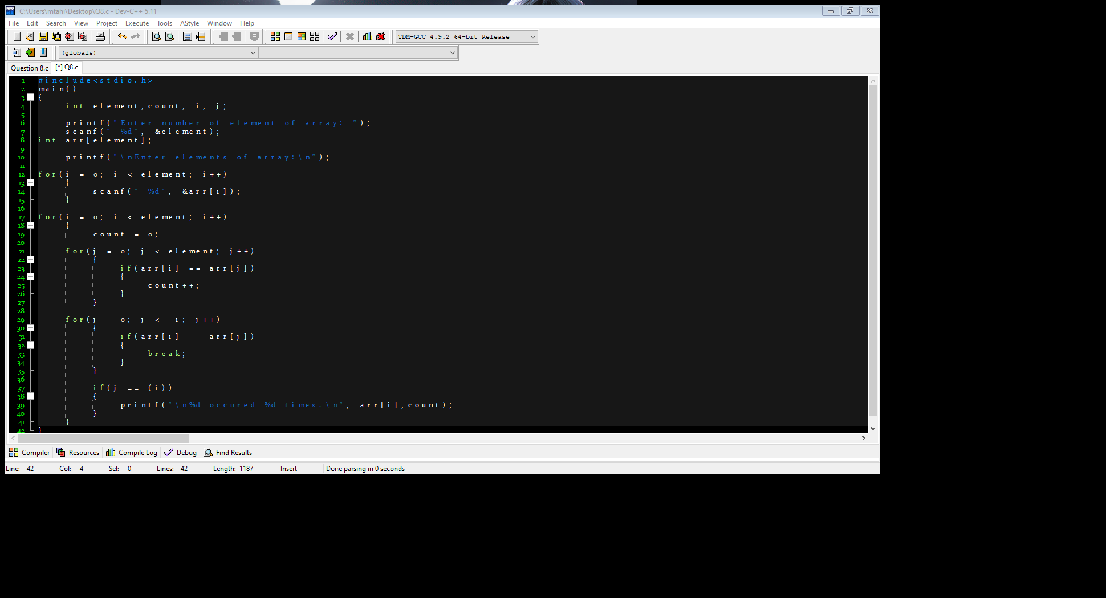

OUTPUT:

